Project 1:Mastermind

Class: CSC-17A 42824

Name: Kayla Rodriguez

Date: 05/05/2016

Introduction

Title: Mastermind

Mastermind is a code breaking game for users to try and guess four different colors the computer picked by random. The user uses hints given by the computer telling them whether their color is in the right spot, or how many of the colors are correct. The user inputs how any attempts they are willing to play, and to win they must guess the correct colors before 10 tries.

Project Description and Checklist:

This project demonstrates the different constructs and learned in class. It utilizes concepts from chapters nine through 12 but does include a few concepts from chapter 13.

Size: 550 lines

Concepts Utilized For Project From Ch 9-12:

* Structures
* Pointers with arrays
* Arrays of structures
* Structure types passed into functions
* String objects
* String class
* Reading a binary file
* Opening a binary file
* Writing a binary file
* Allocated memory
* Functions that return structure object variables
* Inputting a structure variable
* Outputting a structure variable

Additional Concepts Utilized

* Classes
* Accessor and Mutator Functions within a class
* Separate cpp files and header files for the class
* Private member variables
* Public member functions
* Vectors
* Push_back( ) function
* Tables
* Character arrays
* Returning a char pointer within a function
* Converting character arrays to strings
* Random function generator

Variables Used, Types and Descriptions within the Declare Variables part of Main

|  |  |  |
| --- | --- | --- |
| Type | Variable Name | Description |
| const int | SIZE=4 | Size variable of four used for for loops, for example, to input the four colors, to generate the computer’s colors |
| UserColor | *clrPick | Pointer of structure type UserColor which holds the user’s color pick and spot number of the color |
| string | order[SIZE] | An array which contains the strings “first”, “second”, “third”, “fourth” which is used in a for loop to print out these words during user inputs |
| string | options[8] | Options array contains all the available color options for the user and the computer to pick from |
| ComColor | cColor[SIZE] | Array of class type ComColor which contains the computer generated pick of each of the colors |
| int | limit=0 | Total limit of the game, the player wins in less than ten tries but the player can choose to play pass this game limit if they choose to by setting this variable |
| const char | GMELMT=10 | Game limit, this determines whether the user has won or lost |
| vector<string> | list | This vector converts characters to one condensed string to be used to be outputted by a table |
| string | *eachPick | Holds an array of each pick options and allocated the memory |
| char | optChar[8] | This array contains the same options as the string options array except now they are represented by characters. This is used to be outputted into a table |
| fstream | infile | The infile variable contains the instructions for the game to be outputted onto the consol. |
| string | instr | The instr variable contains the actual strings to store the instructions from the file |
| fstream | out | The output file instructions variable |
| char | *userChar | User’s color choices but in character form to be outputted in the tablr |
| int | nTrys=0 | Number of tries counter, counts the number of tries the user takes |

Function Prototypes

|  |  |  |
| --- | --- | --- |
| Type | Variable Name | Description |
| char* | compic | Returns a random character for computer generated pick, returns the character representation of the computer’s pick |
| UserColor* | input | User inputs their colors in this function and the spots they want the colors to be in. returns an array of these picks of type UserColor |
| void | switchH | Hints function, displays hints after each guess |
| void | reppic | Representation of previous picks, displays table, and attempt number |
| void | results | Displays win or loss message to the user |
| void | Hints1 | Repeated hints display message made into a function |
| void | Hints2 | Repeated hints display message made into a function |
| void | Hint3 | Repeated hints display message made into a function |
| void | writeFile | This Function writes the output file containing the table of choices, the user’s attempt number and whether they won or lost |
| void | readFile | Reads the contents of the instruction file to show the user the instructions |
| char* | Input2 | Function returns the user’s pick in character form to be outputted to a table |

Concepts Learned and Location in the Code

|  |  |  |
| --- | --- | --- |
| Concept Learned | Chapter (Gaddis) | Location |
| Structures | Chapter 11 | Used to return a character to generate computer generated picks within the compic function |
| Pointers with arrays | Chapter 9 | Used in many places of the code to store color picks, char pointers used, string pointers, and structure pointers used |
| Arrays of structures | Chapter 11 | Used to store the user’s color pick and spot number |
| Structure types passed into functions | Chapter 11 | Used in majority of functions to use the contents of the UserColor structure and access which colors the user picked |
| String objects/classes | Chapter 10 | Used in multiple places in char arrays, converting characters to strings, array types, variable names |
| Reading a binary file | Chapter 12 | Used to read in the instructions file |
| Opening a binary file | Chapter 12 | Used to open the instructions file and the results file |
| Writing a binary file | Chapter 12 | Writes the results of the game to a binary file |
| Allocated memory | Chapter 9 | Used to return computer’s choices char array, used to return user’s choices char array, used to create a new array of type UserColor, and used to create a new each pick array. All four used allocated memory and all of the memory used was deleted at the end of the program (“cleaning after yourself”) |
| Functions that return structure object variables | Chapter 11 | Input function contains all the user input and returns the UserPick array |
| Inputting /Outputting a structure variable | Chapter 11 | This is used to have the user input their choices, and at the end to output the contents of this array |

Pseudo Code

Declare/Initialize Variables

Initialize counter

Introduction to Game

Modify limit of attempted games

Computer Generated Pick Function

Returns a primitive data type char

Displays The Introduction to the game that was written in a file, explains how the game works

Input function

User inputs their first color choices, if user picks an option invalid, displays message again

Representation of pick function

Displays table of what user picked so far, the number attempt they are on

If guessed correctly, program displays win message

SwitchH function (shows hints after each play)

User presses one to see hints for all of their picks (how many are in the right spot and how many are correct but not in the right spot).

Default: No hints displayed

Hints displayed after each new guess

Number of tries Counter

Increments the number of tries after the switch function displays

Outputs Result

Reveals to the user the computer’s choice

If the user can guess in below 10 tries, they won and output displays message that they won and the percentage of the board they took up.

Else displays lose message

Write the output file the user’s results

End

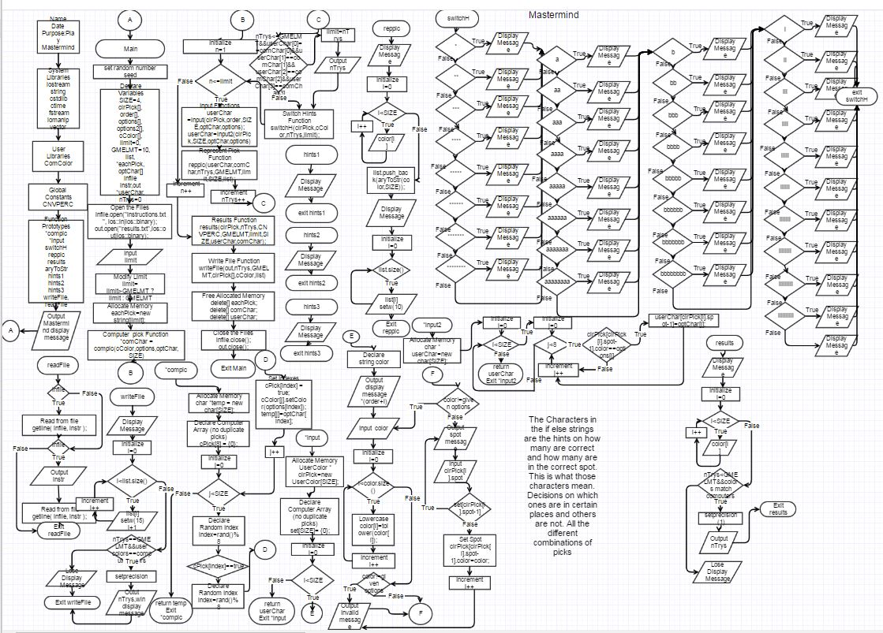The Entire Game Flowcharted with all of its functions included (This is included separately in the folder) More zoomed photos of this flowchart is included in project folder if needed